

**MCA SEMESTER III PROJECT REPORT**

SUBMITTED IN PARTIAL FULLFILLMENT

OF THE REQUIREMENTS FOR

THE AWARD OF THE DEGREE OF

MASTER OF COMPUTER APPLICATIONS

**SCHOOL OF COMPUTING**

**SUBMITTED BY,**

**NAME OF STUDENTS ROLL NUMBERS**

MEVADA SANJANA 241135

BHAYANI DHRUVI 241137

**SUPERVISED BY,**

PROF. SANAJNA JAYSWAL

JG UNIVERSITY

SEPTEMBER 2025

ACKNOWLEDGEMENT

We would like to express our sincere gratitude to everyone who supported us throughout the development of our project *“Corporate Recruitment System.”*

First, we extend our heartfelt thanks to our guide, **Prof. Sanjana Jayswal**, for providing constant guidance, valuable suggestions, and continuous encouragement during this project. Her insights and support have been extremely helpful in shaping this work.

We would also like to thank **JG University** for providing us with the opportunity and resources to carry out this project successfully.

A special thanks to my teammate **Sanjana Mevada**, whose dedication, hard work, and collaborative spirit made this project truly successful. Our teamwork and mutual understanding enabled us to execute every phase smoothly, and our strong bond ensured a positive and productive environment throughout.

I, **Dhruvi Bhayani**, would also like to acknowledge the support from the company where I am currently working as a **Trainee Software Developer**. The practical knowledge, technical exposure, and guidance provided by my company greatly helped me in implementing real-world features in this project. Their mentorship and encouragement played a key role in improving the quality of our work.

Finally, we express our appreciation to all classmates, friends, and faculty members who directly or indirectly contributed to the successful completion of this project.

INDEX

|  |  |  |
| --- | --- | --- |
| **SERIAL NO.** | **TOPIC NAME** | **PAGE NO.** |
| 1 | COLLEGE CERTIFICATE |  |
| 2 | PROJECT PROFILE   * INTRODUCTION TO PROJECT * MODULES * EXISTING SYSTEM * PROPOSED SYSTEM * TOOLS AND TECHNOLOGY | 4 TO 9 |
| 3 | SYSTEM FLOW | 10 |
| 4 | UML DIAGRAM   * USE-CASE * CLASS * ACTIVITY | 11 TO 17 |
| 5 | DATA DICTIONARY | 18 TO 20 |
| 6 | TEST CASES | 21 TO 22 |
| 7 | SCREEN LAYOUT   * VISITOR SIDE LAYOUT * ORG SIDE LAYOUT * JOB-SEEKER SIDE LAYOUT | 23 TO 33 |
| 8 | CONCLUSION | 34 |
| 9 | BIBILIOGRAPHY | 34 |

Introduction

* The **Corporate Recruitment System** is a smart and efficient platform designed to streamline the hiring process within organizations.
* It allows companies to post job openings, receive online applications, and manage the entire recruitment cycle in one centralized system.
* The system brings **transparency and fairness** by providing equal opportunities for all applicants and ensuring unbiased recruitment.
* It maintains a **centralized database of applicants**, making future hiring faster and easier.
* Through **role-based access**, HR, Managers, and Admins can manage applications according to their responsibilities.
* With **automated application tracking**, candidates can follow their status (applied, shortlisted, interviewed, selected) in real-time.
* The system also improves the **candidate experience** by providing a simple and professional application process.
* Finally, it enables **reporting and analytics**, giving organizations insights into hiring trends, efficiency, and workforce planning.

MODULES

There are three types of users in our system :

* + - * + ORGANIZATION
        + JOB SEEKER
        + VIEWER

|  |  |  |
| --- | --- | --- |
| ORGANIZATION | JOB SEEKER | VIEWER |
| |  | | --- | | Login | | |  | | --- | | Register / Login | | |  | | --- | | Register | |
| |  | | --- | | Organization Registration | | |  | | --- | | View All Job Openings | | |  | | --- | | View All Open Jobs | |
| |  | | --- | | Create Job | | |  | | --- | | Apply for a Job | | |  | | --- | | Search Jobs | |
| |  | | --- | | Update / Close / Re-open Job | | |  | | --- | | Upload Resume / Documents | | |  | | --- | | View Job Details | |
| |  | | --- | | View All Job Applications | | |  | | --- | | View Application Status (Applied, Screening, Shortlisted, Interview, Selected, Rejected) | | |  | | --- | | Contact Us | |
| |  | | --- | | Manage Application Status (Applied → Screening → Shortlisted → Interview → Selected/Rejected) | | |  | | --- | | Receive Application Status Notifications | | |  | | --- | | Give Feedback | |
| |  | | --- | | Shortlist Candidates | | |  | | --- | | Update Profile (Skills, Summary, Resume) | | |  | | --- | |  | |
| |  | | --- | | Schedule Interviews | | |  | | --- | | Give Feedback | | |  | | --- | |  | |
| |  | | --- | | Add Recruiter Notes | |  |  |
| |  | | --- | | Select / Reject Applications | |  |  |
| |  | | --- | | View Reports / Feedback | |  |  |
| |  | | --- | | View Candidate Profiles & Resumes | |  |  |

Project profile

Existing system :

* Recruitment is carried out manually or through basic job portals.
* Candidates apply via email or submit physical resumes.
* HR manually shortlists applications using spreadsheets.
* Communication (interview calls, updates) is done by phone or email.
* Records are stored in scattered files/folders, not centralized.
* Reporting and analysis of recruitment data is difficult.
* Time-consuming, error-prone, and lacks transparency.

Proposed system :

* Fully automated **Corporate Recruitment System**.
* Candidates can register, create profiles, and apply for jobs online.
* Centralized database stores candidate and job information.
* HR/Admin can easily post jobs, shortlist candidates, and schedule interviews.
* Role-based access (Admin, HR, Employee, Candidate).
* Real-time application status tracking for candidates.
* Automatic email/SMS notifications for updates.
* Generates detailed reports and analytics for better decision-making.
* Saves time, reduces errors, and increases transparency.

Development tools & technology

Frontend :

* HTML5
* CSS3
* BOOTSTRAP5
* JAVASCRIPT
* ReactJS

Backend :

* Node.js
* MySQL

Tools :

* VS Code
* Postman
* GitHub
* Draw.io
* MS Word
* MS PowerPoint

MINIMUM HARDWARE REQUIREMENT :

* PROCESSOR: 32-BIT OPERATING SYSTEM
* SPEED: 1GHZ CPU AND ABOVE
* RAM: 4GB
* HARD-DISK SPACE: 500 MB DISK SPACE

MAXIMUM SOFTWARE REQUIREMENT :

* OPERATING SYSTEM: WINDOWS 10/11
* BROWSER: GOOGLE CHROME, MOZILLA FIREFOX, Edge, LATEST VERSION
* DATABASE: MYSQL

SYSTEM FLOW DIAGRAM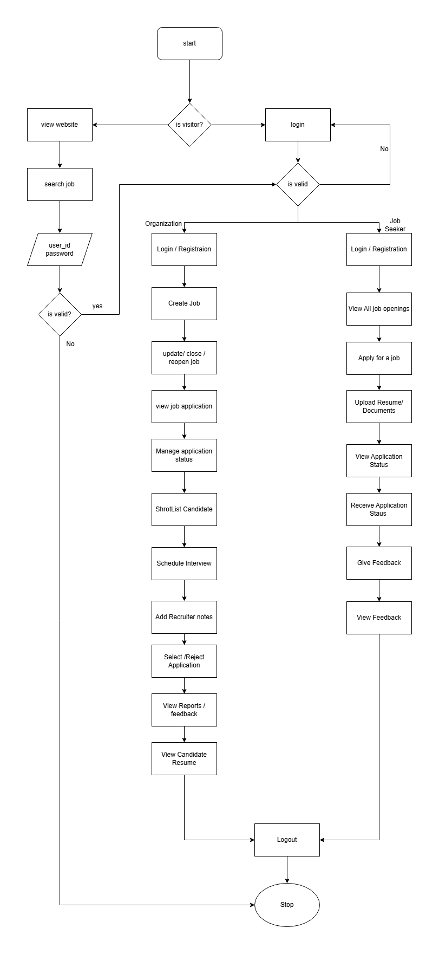

USE-CASE DIAGRAM

Use-case for visitor

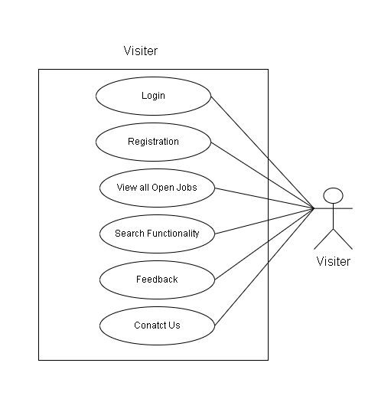

Use-case for organization

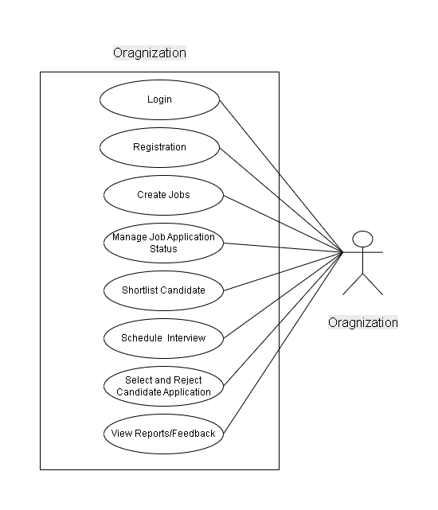

Use-case for a job seeker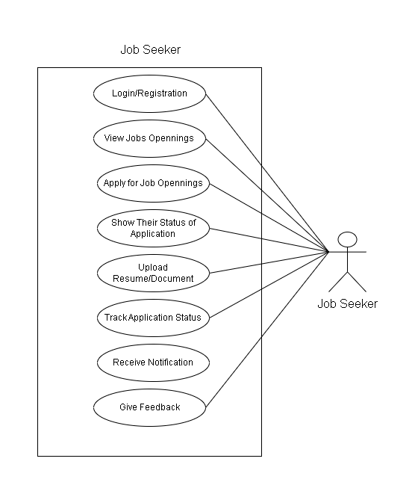

class diagram

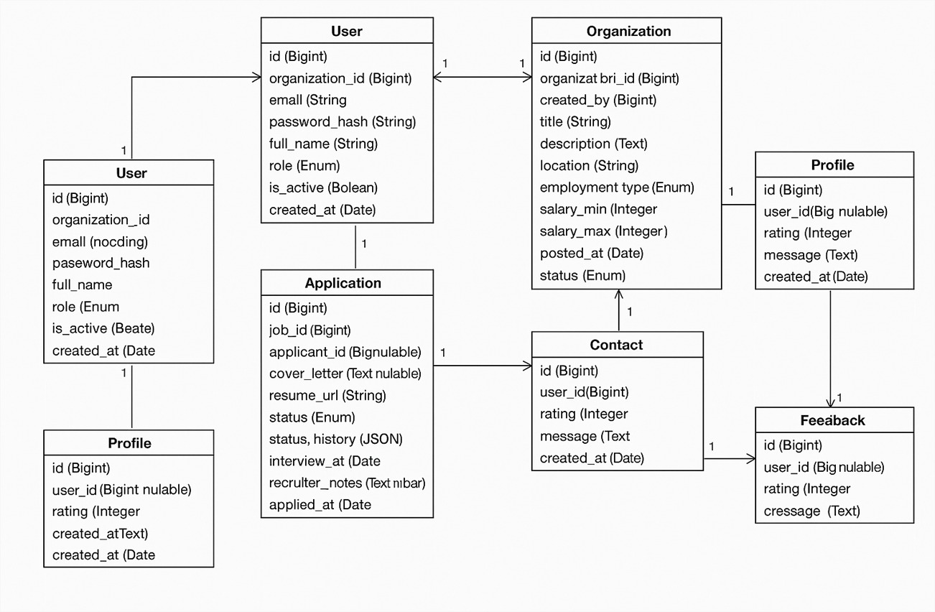

ACTIVITY DIAGRAM

* ACTIVITY FOR REGISTRATION

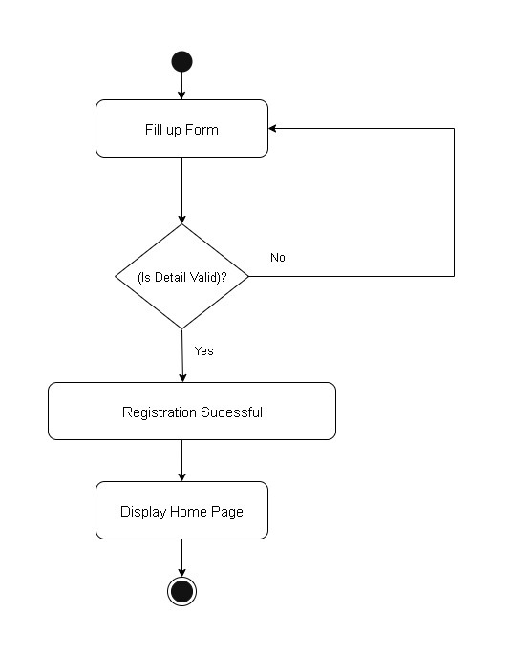

* ACTIVITY FOR LOGIN

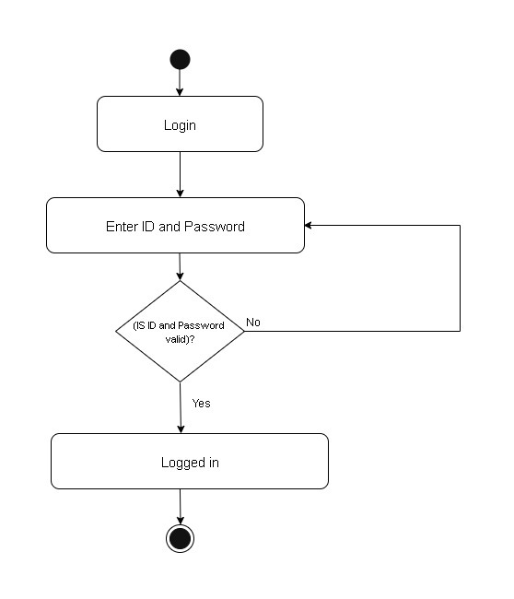

* ACTIVITY FOR SEARCH

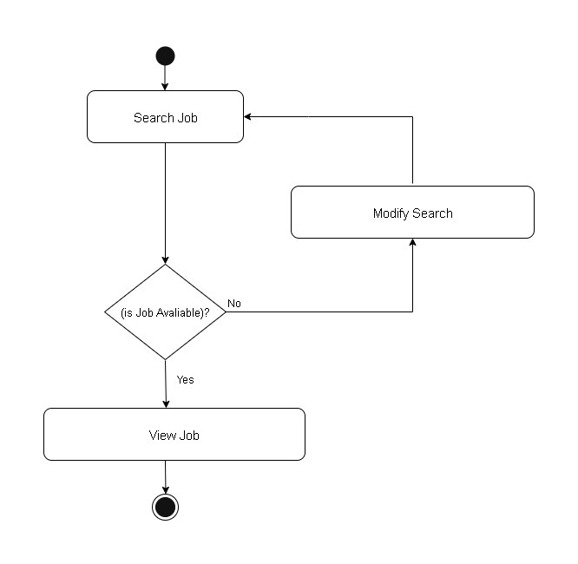

* ACTIVITY FOR APPLYING FOR A JOB

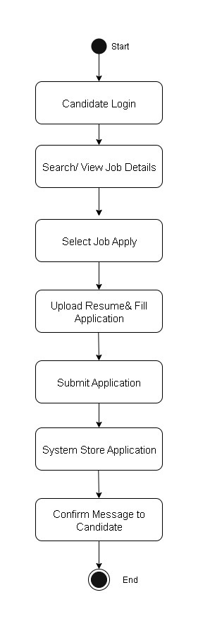

* ACTIVITY FOR ATTENDING INTERVIEW

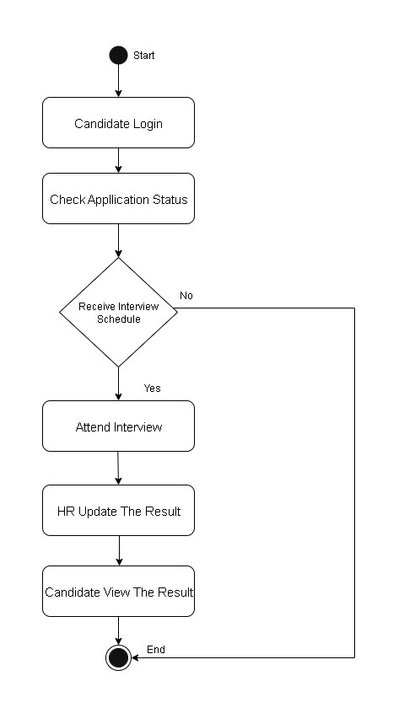

DATA DICTIONARY

1. USERS TABLE

|  |  |  |  |
| --- | --- | --- | --- |
| **Name** | **Data Type** | **Constraints** | **Description** |
| id | BIGINT | PK, Auto Increment | Unique user ID |
| organization_id | BIGINT | FK → organizations.id, Nullable | Organization ID |
| email | VARCHAR | Not Null, Unique | Email address |
| password_hash | VARCHAR | Nullable | Hashed password |
| full_name | VARCHAR | Nullable | Full name |
| role | ENUM | Not Null | User role |
| is_active | BOOLEAN | Default true | Active status |
| invite_token | VARCHAR(128) | Nullable | Invite token |
| otp_code | VARCHAR | Nullable | OTP code |
| otp_expiry | DATETIME | Nullable | OTP expiration |
| is_verified | BOOLEAN | Default false | Email verified |
| reset_otp | VARCHAR | Nullable | Reset OTP |
| reset_expiry | DATETIME | Nullable | Reset expiry |
| created_at | DATETIME | Default NOW | Created date |

1. organizations TABLE

|  |  |  |  |
| --- | --- | --- | --- |
| **Name** | **Data Type** | **Constraints** | **Description** |
| id | BIGINT | PK Auto Increment | Organization ID |
| name | VARCHAR | Not Null | Organization name |
| domain | VARCHAR | Nullable | Email domain |
| created_at | DATETIME | Default NOW | Created date |

1. jobs TABLE

|  |  |  |  |
| --- | --- | --- | --- |
| **Name** | **Data Type** | **Constraints** | **Description** |
| id | BIGINT | PK Auto Increment | Job ID |
| organization_id | BIGINT | FK → organizations.id | Organization ID |
| created_by | BIGINT | FK → users.id | Creator ID |
| title | VARCHAR | Not Null | Job title |
| description | TEXT | Nullable | Job description |
| location | VARCHAR | Nullable | Job location |
| employment_type | ENUM | Nullable | Job type |
| salary_min | INTEGER | Nullable | Minimum salary |
| salary_max | INTEGER | Nullable | Maximum salary |
| posted_at | DATETIME | Default NOW | Posted date |
| status | ENUM | Default open | Job status |

1. Applications TABLE

|  |  |  |  |
| --- | --- | --- | --- |
| **Name** | **Data Type** | **Constraints** | **Description** |
| id | BIGINT | PK Auto Increment | Application ID |
| job_id | BIGINT | FK → jobs.id | Job ID |
| applicant_id | BIGINT | FK → users.id | Applicant ID |
| cover_letter | TEXT | Nullable | Cover letter |
| resume_url | VARCHAR(1024) | Nullable | Resume link |
| status | ENUM | Default applied | Workflow status |
| status_history | JSON | Default [] | Status logs |
| interview_at | DATETIME | Nullable | Interview date |
| recruiter_notes | TEXT | Nullable | HR notes |
| applied_at | DATETIME | Default NOW | Applied date |

1. feedback table

|  |  |  |  |
| --- | --- | --- | --- |
| **Name** | **Data Type** | **Constraints** | **Description** |
| id | BIGINT | PK Auto Increment | Feedback ID |
| user_id | BIGINT | FK → users.id | User ID |
| rating | INTEGER | Not Null | Rating |
| message | TEXT | Not Null | Feedback text |
| created_at | DATETIME | Default NOW | Created date |

1. profiles TABLE

|  |  |  |  |
| --- | --- | --- | --- |
| **Name** | **Data Type** | **Constraints** | **Description** |
| id | BIGINT | PK Auto Increment | Profile ID |
| user_id | BIGINT | Unique, FK → users.id | User ID |
| headline | VARCHAR | Nullable | Headline |
| summary | TEXT | Nullable | Summary |
| resume_url | VARCHAR(1024) | Nullable | Resume link |
| skills | JSON | Nullable | Skills list |
| created_at | DATETIME | Default NOW | Created date |

1. contact message table

|  |  |  |  |
| --- | --- | --- | --- |
| **Name** | **Data Type** | **Constraints** | **Description** |
| id | BIGINT | PK Auto Increment | Message ID |
| name | VARCHAR | Not Null | Sender name |
| email | VARCHAR | Not Null | Sender email |
| phone | VARCHAR | Nullable | Phone number |
| subject | VARCHAR | Not Null | Subject |
| message | TEXT | Not Null | Message text |
| created_at | DATETIME | Default NOW | Created date |

Test cases

|  |  |  |  |  |  |  |
| --- | --- | --- | --- | --- | --- | --- |
| **TEST CASE ID** | **TEST CASE DESCRIPTION** | **TEST STEPS** | **TEST DATA** | **EXPECTED RESULT** | **ACTUAL RESULT** | **PASS/FAIL** |
| 1 | Valid Registration | 1.Go to register  2.Enter name  3.Enter email  4.Enter password  5.Click Register | Name=Dhruvi  Email=dhruvi@gmail.com  Password=Dhruvi@123 | User should register successfully | As expected | Pass |
| 2 | Invalid Email Registration | 1.Go to register  2.Enter invalid email  3.Click Register | Email=dhruvi@com | Show invalid email error | As expected | Pass |
| 3 | Valid Login | 1.Go to login  2.Enter email  3.Enter password  4.Click Login | Email=dhruvi@gmail.com  Password=Dhruvi@123 | Login successful | As expected | Pass |
| 4 | Invalid Password Login | 1.Go to login  2.Enter email  3.Enter wrong password | Password=Wrong@123 | Show incorrect password message | As expected | Pass |
| 5 | Apply for Job | 1.Login  2.Open job  3.Click apply | JobID=101 | Application submitted successfully | As expected | Pass |
| 6 | Duplicate Job Apply | 1.Login  2.Apply again | Already applied | Show duplicate application message | As expected | Pass |
| 7 | Resume Upload | 1.Login  2.Go to profile  3.Upload resume | resume.pdf | Resume uploaded | As expected | Pass |
| 8 | Create Job (Organization) | 1.Login Org  2.Create job  3.Enter details  4.Save | Title=Software Engineer | Job created | As expected | Pass |
| 9 | Shortlist Candidate | 1.Login Org  2.Open applications  3.Select candidate  4.Change status | Status=Shortlisted | Status updated | As expected | Pass |
| 10 | Schedule Interview | 1.Login Org  2.Open candidate  3.Select interview  4.Set date & time  5.Save | 25 Feb 2025, 2PM | Interview scheduled | As expected | Pass |

Screen layout for the visitor

* Home Page

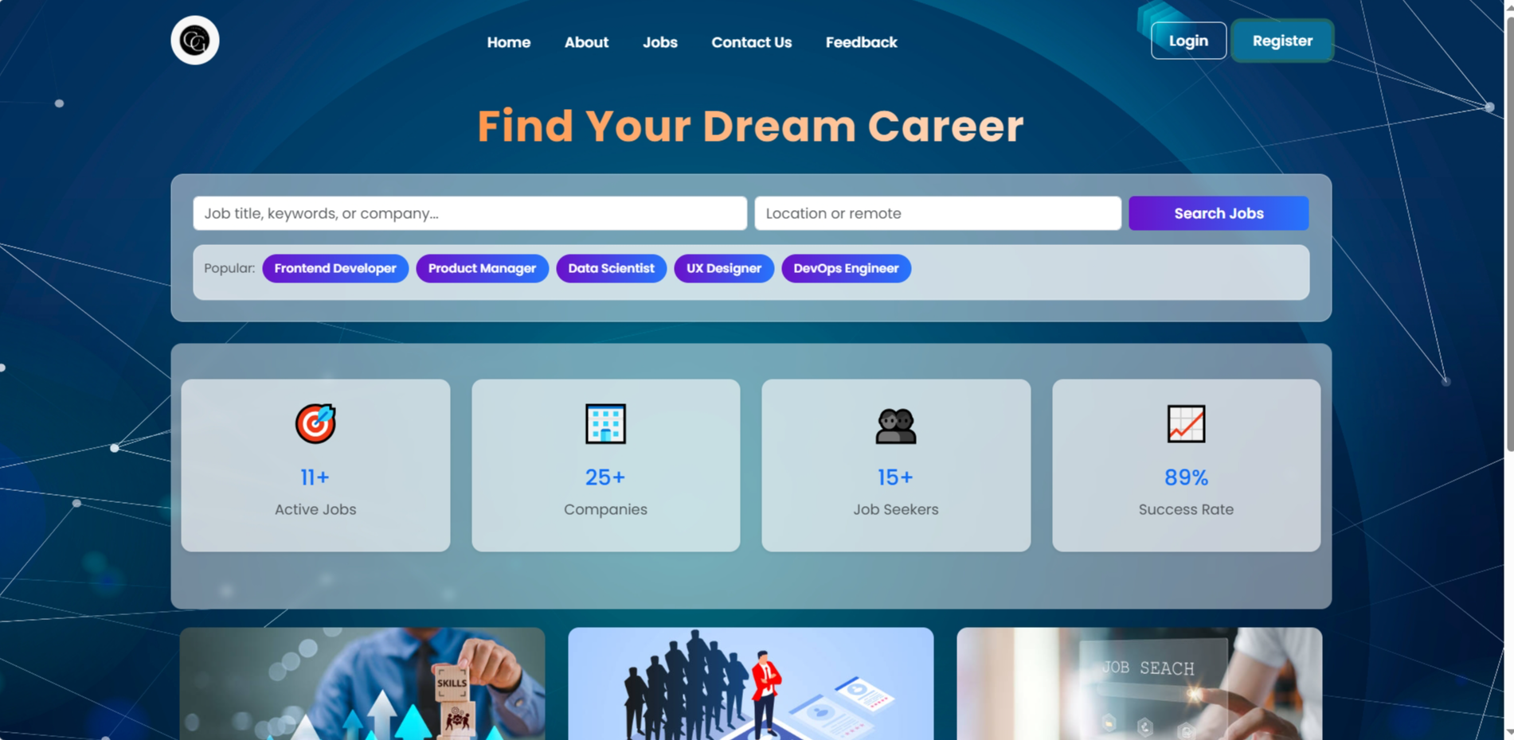

* View All Open Jobs Page

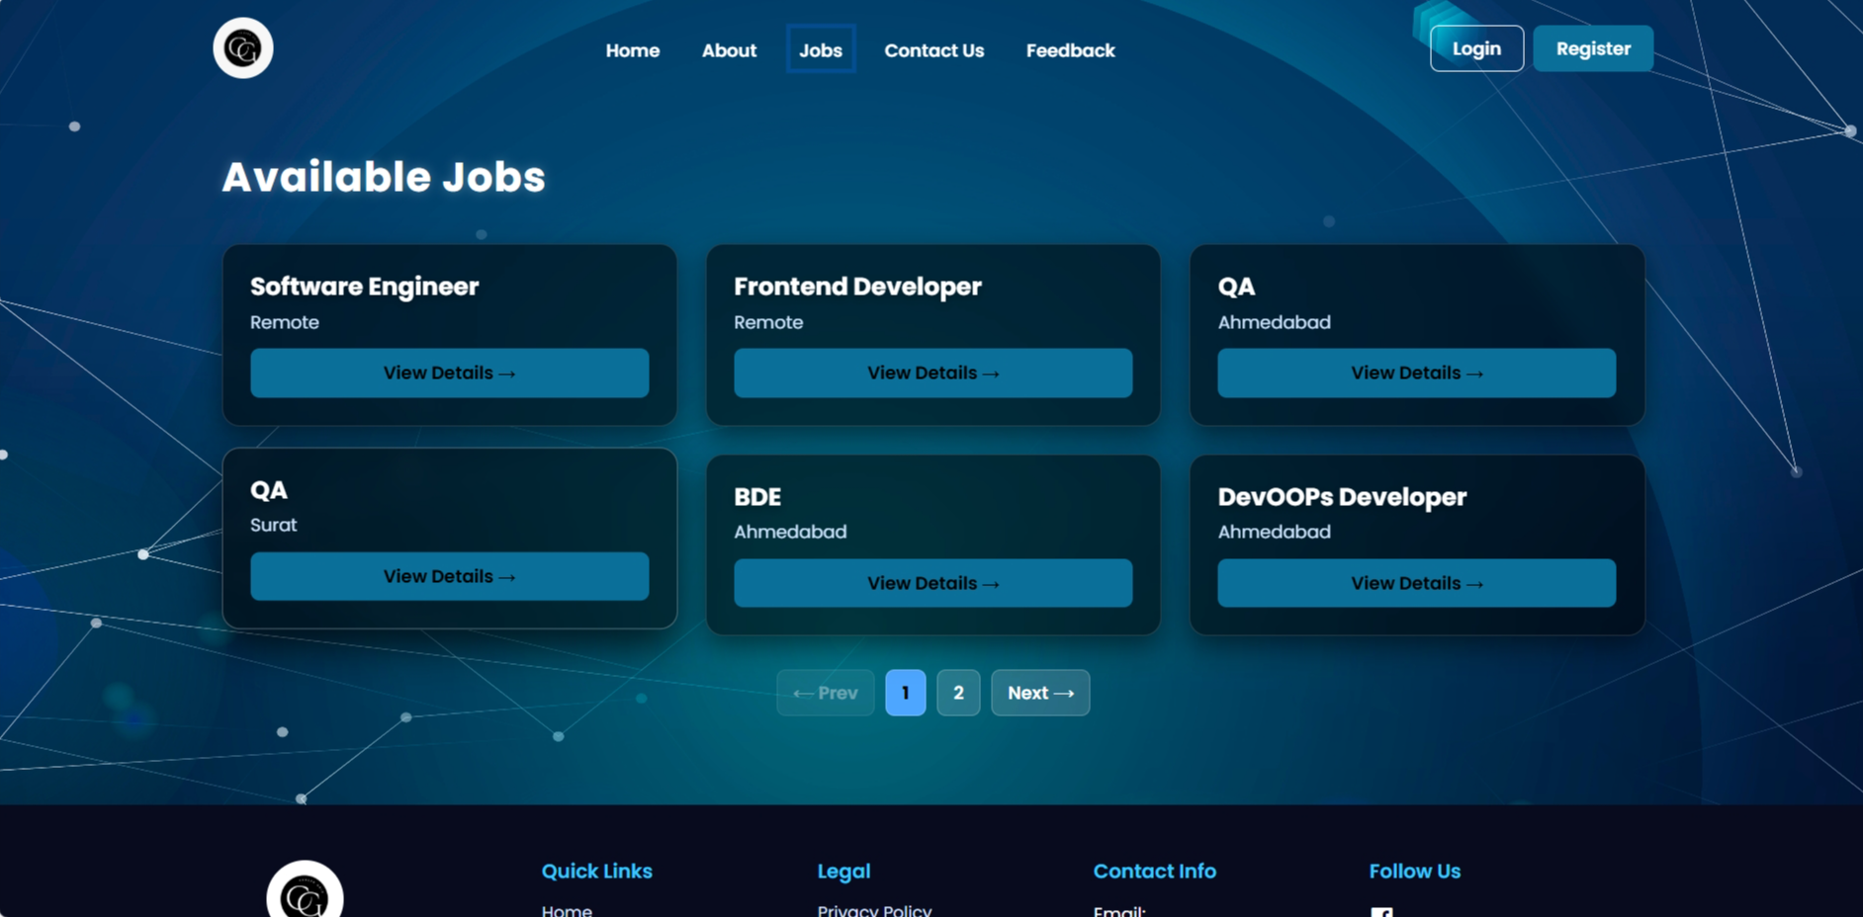

* Search Jobs Page

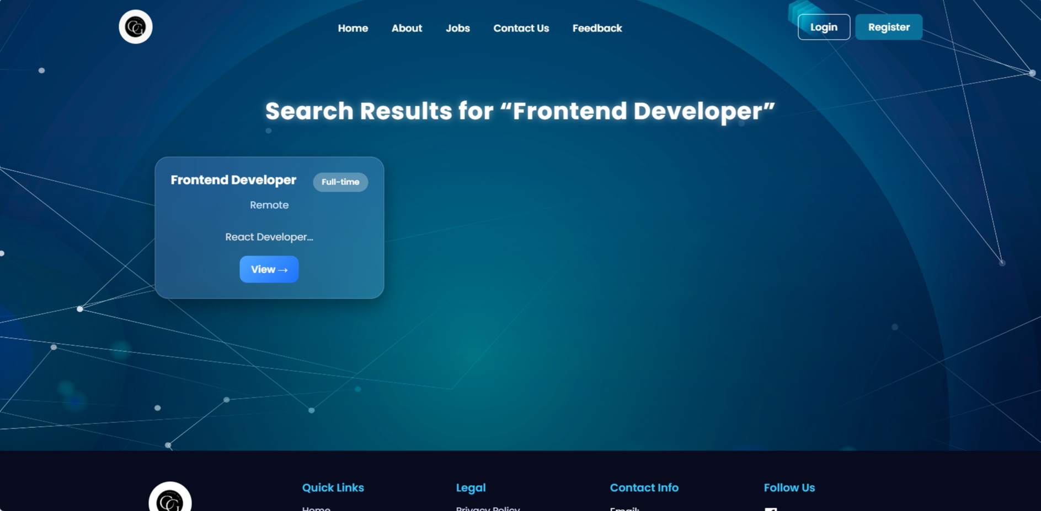

* Job Details Page

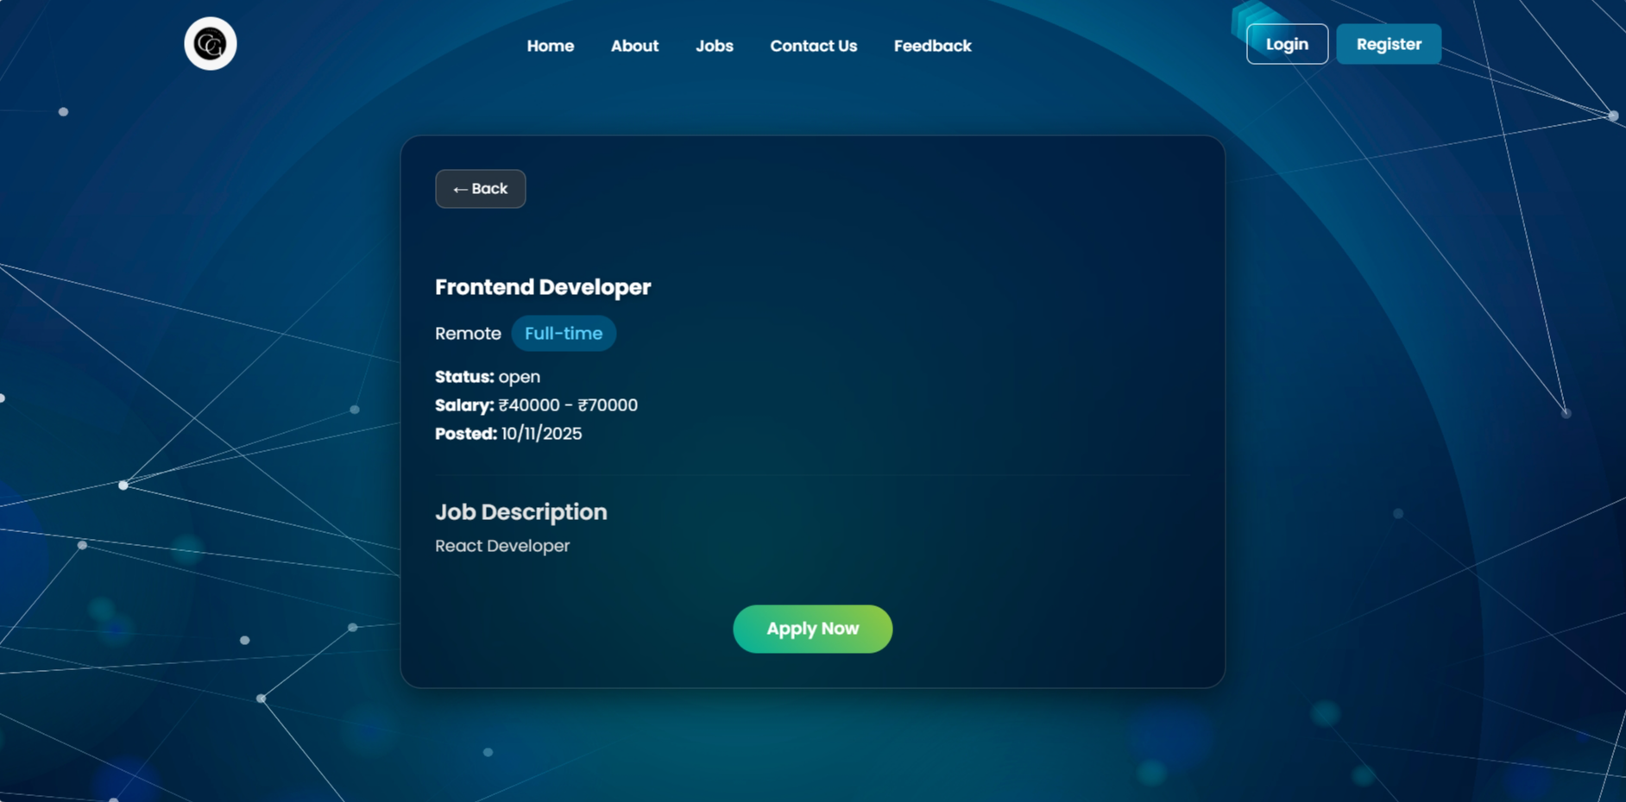

Screen layout for the organization

* Organization Registration from

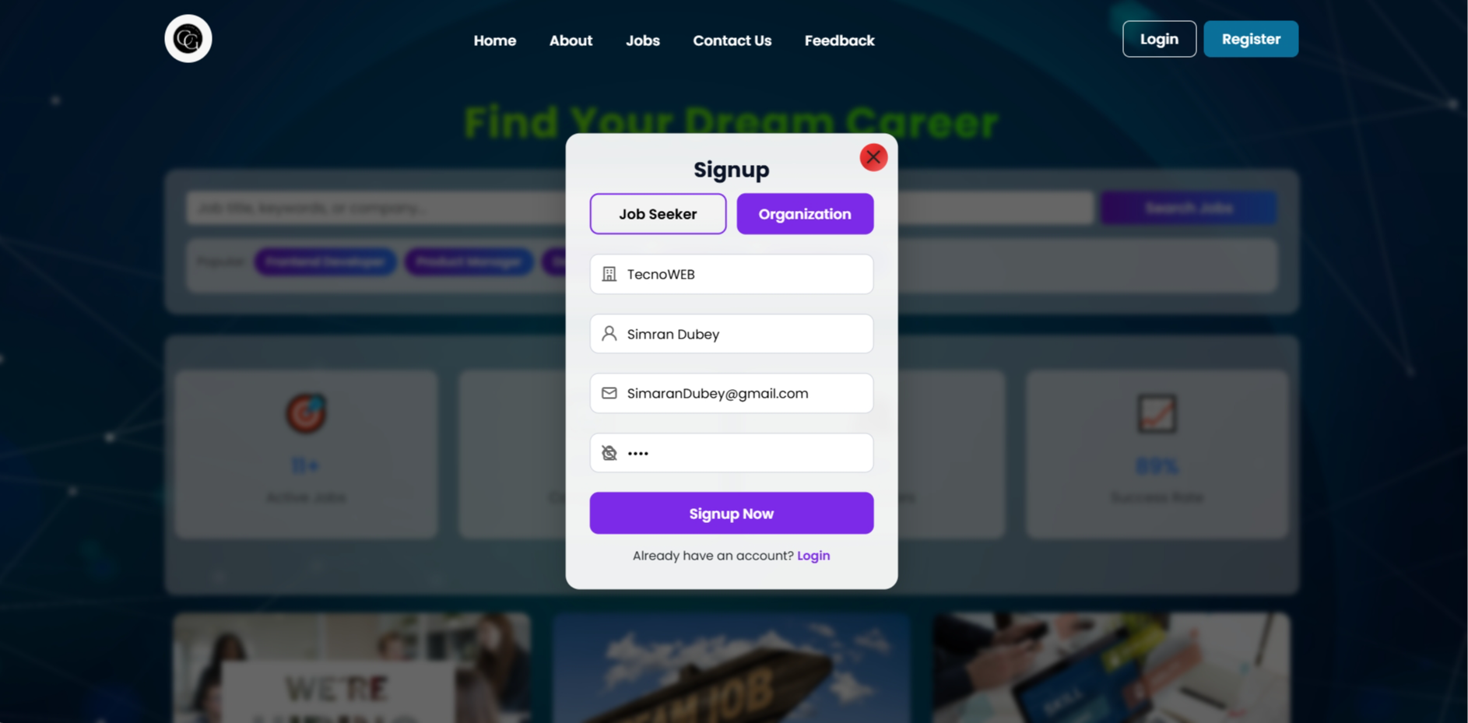

* Organization Dashboard

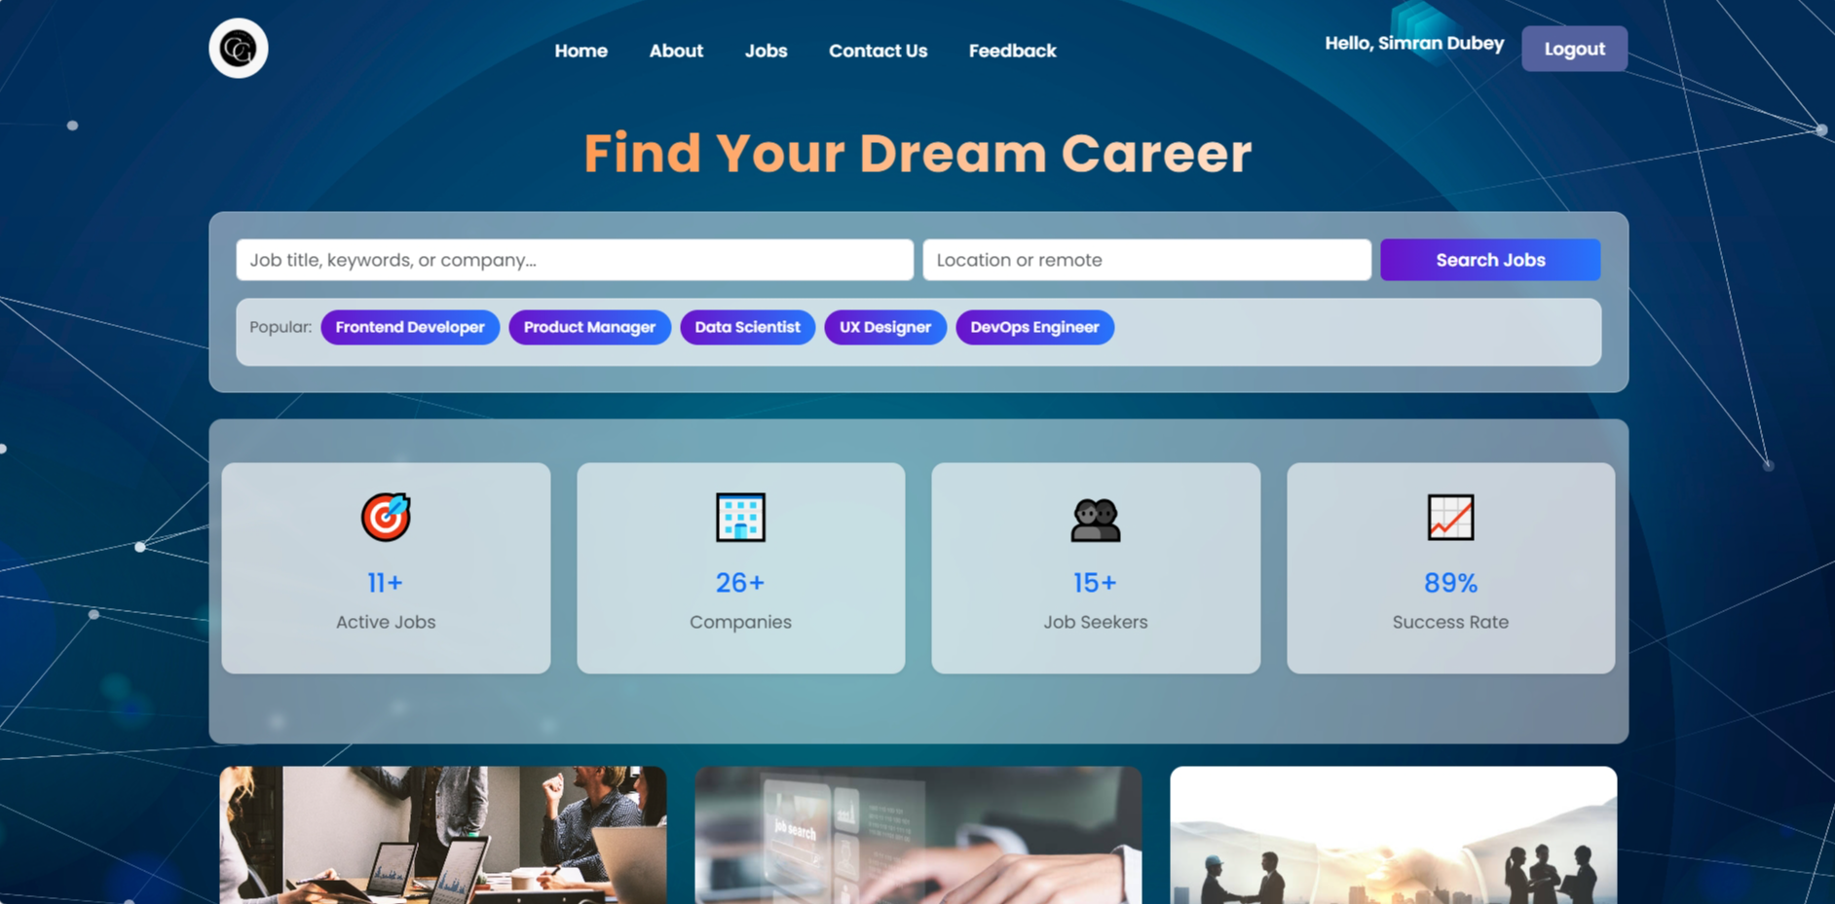

* Create Job Page

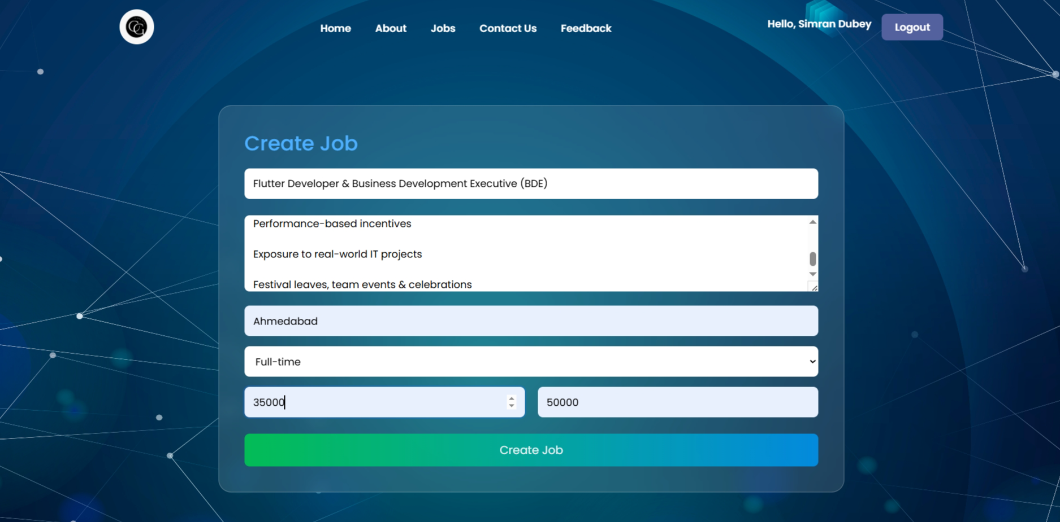

* Job List / Manage Job Page

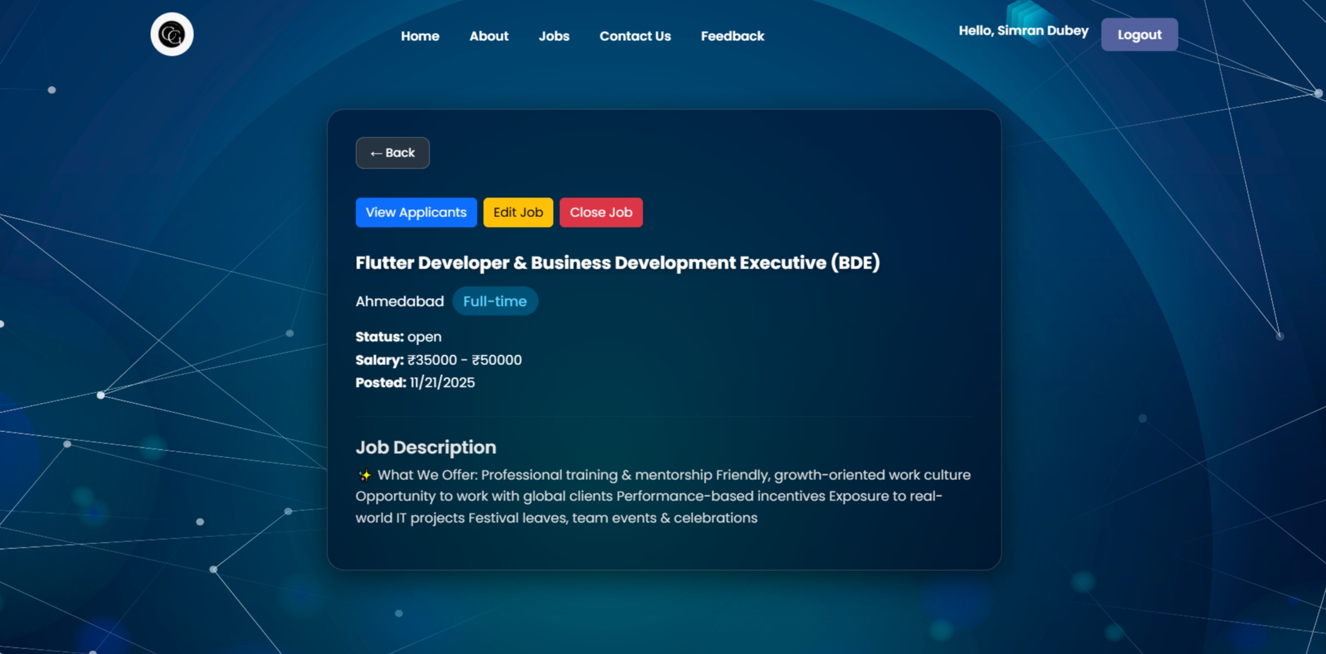

* Candidate Application Details Page

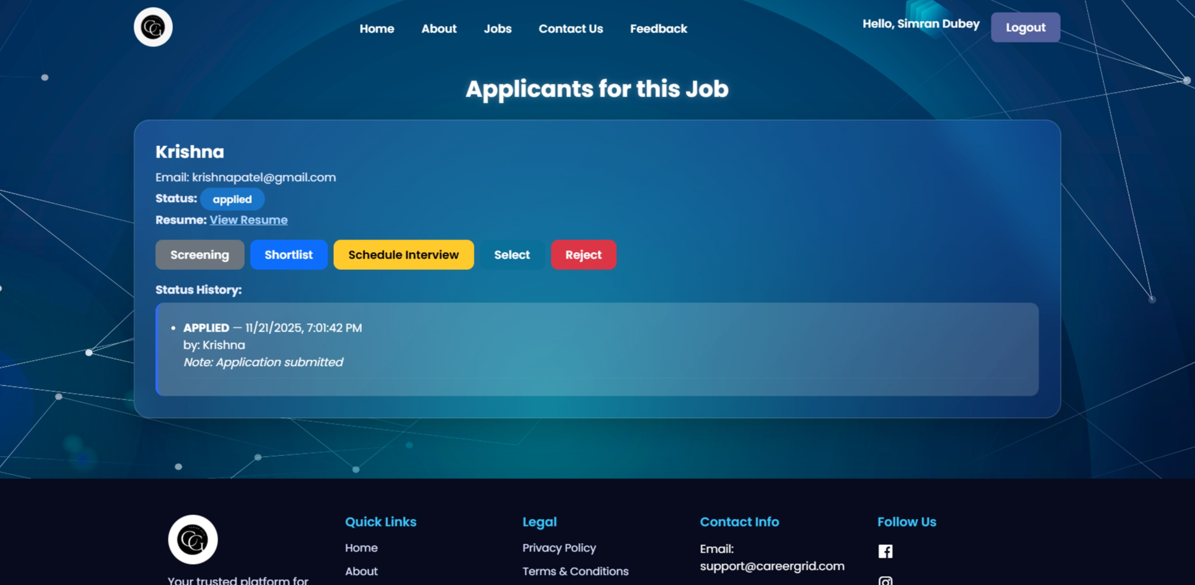

* Schedule Interview Page

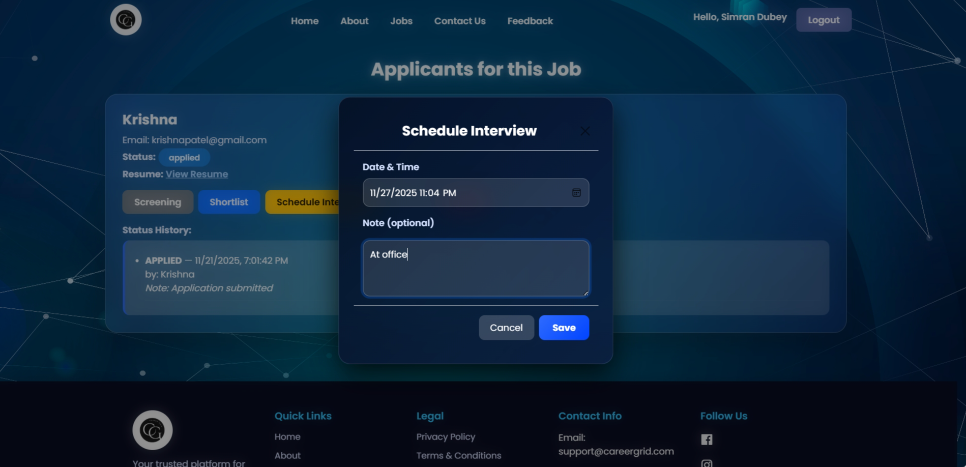

* View Candidate Resume Page

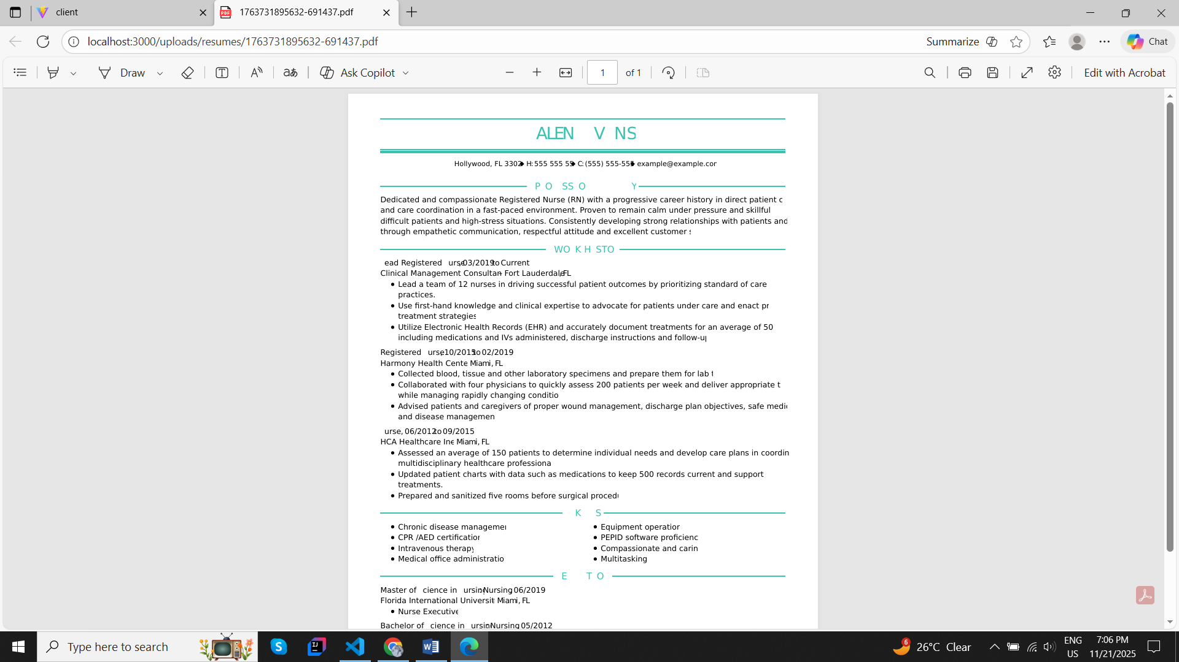

Screen layout for a job seeker

* Job Seeker Registration

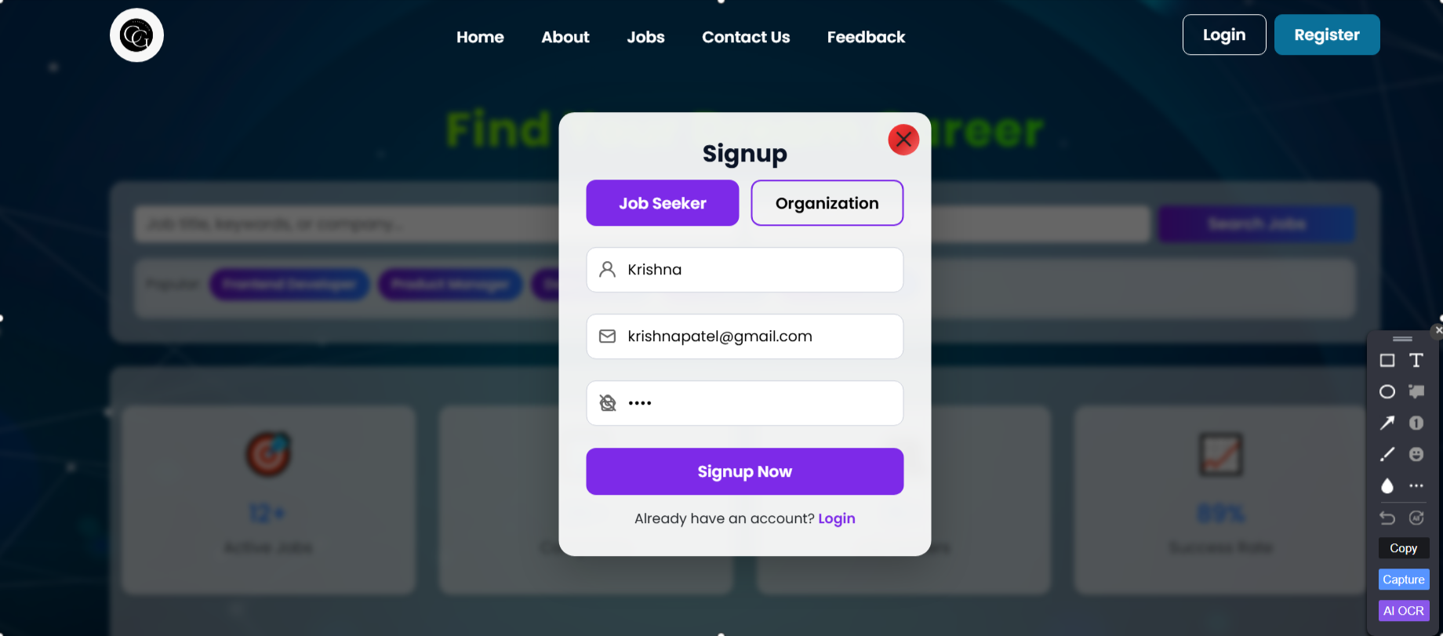

* Job Seeker Dashboard

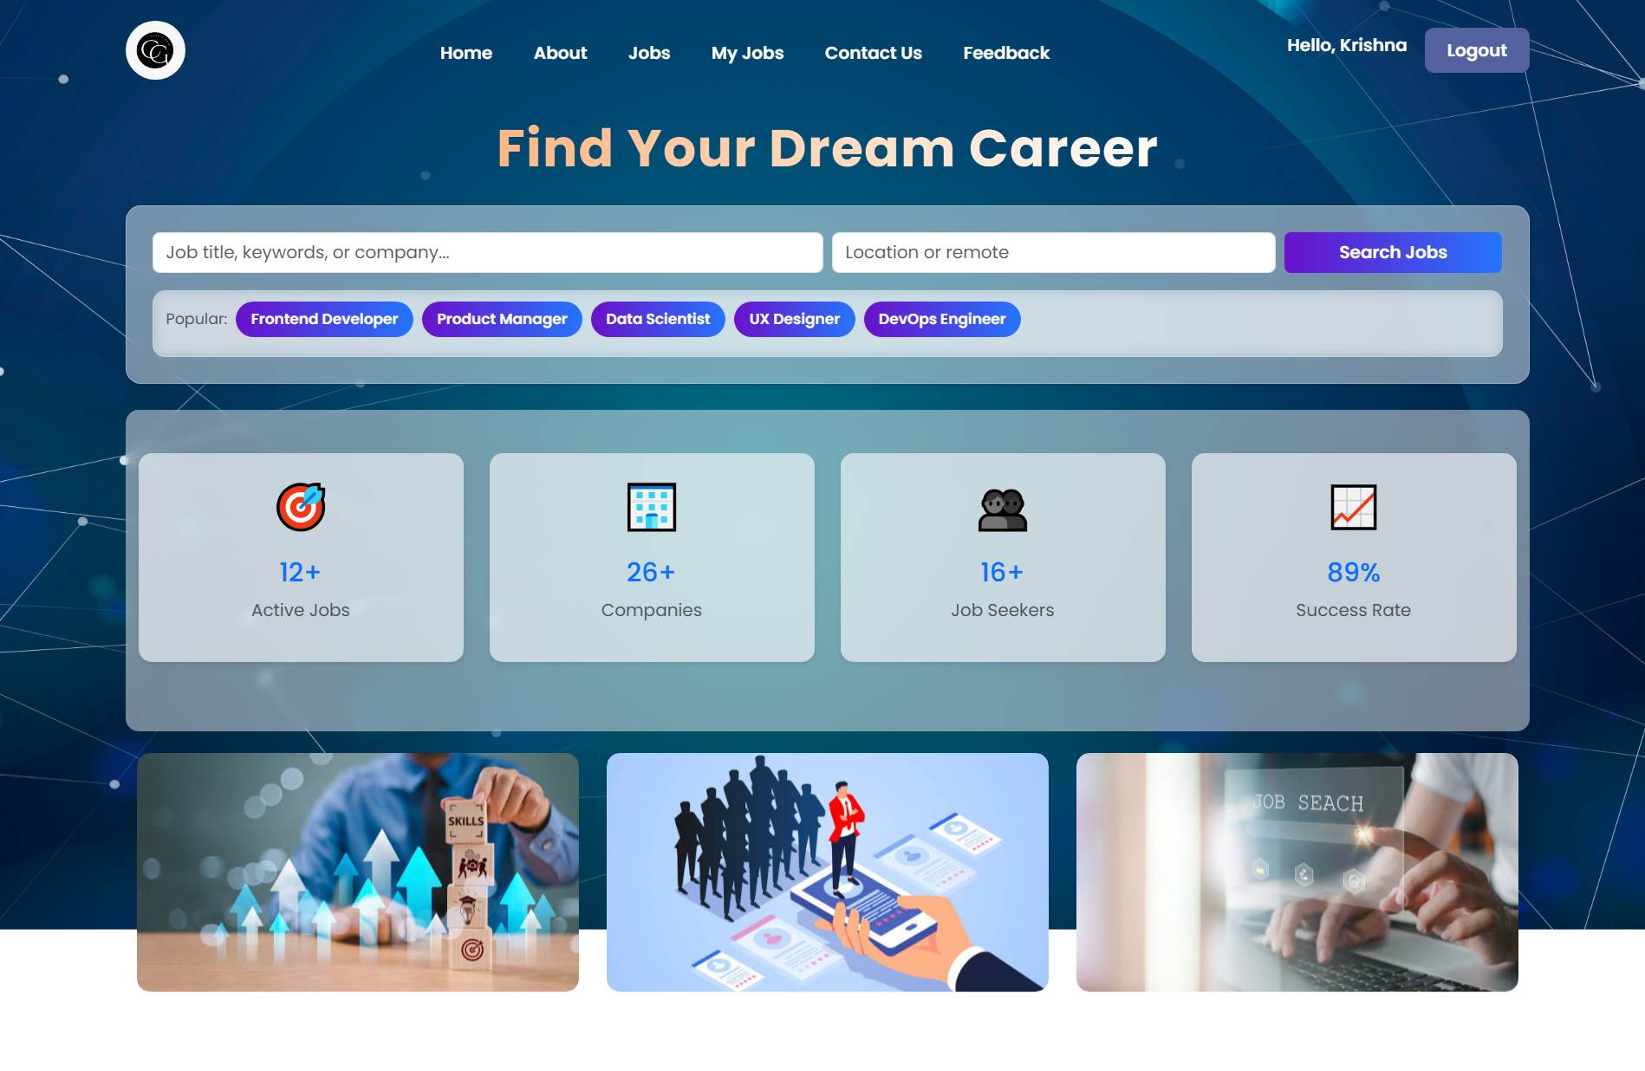

* View All Jobs

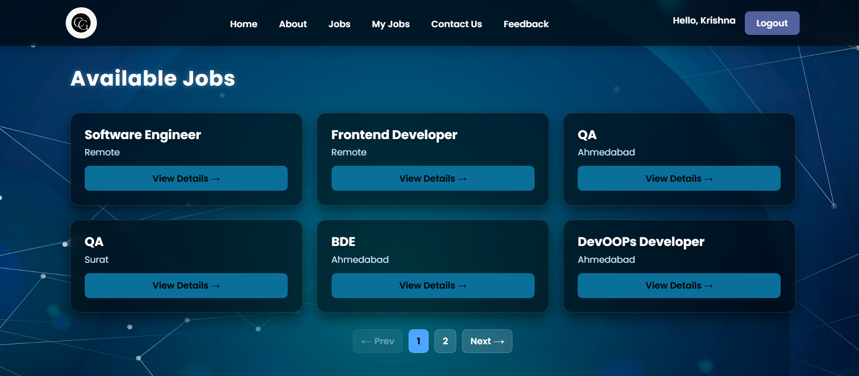

* Job Details Page

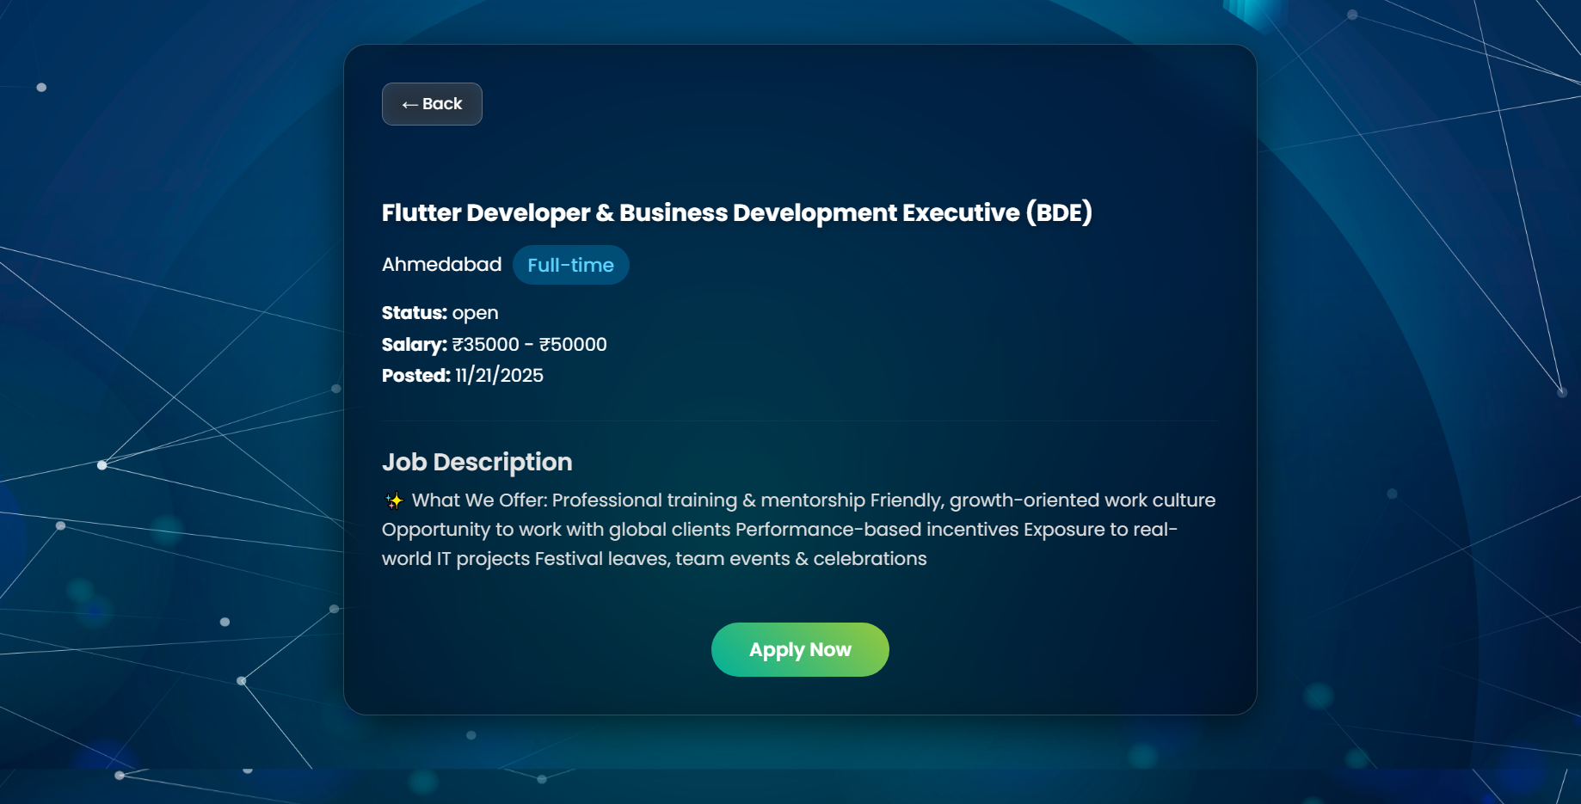

* Apply Job Success Page(Getting Mail)

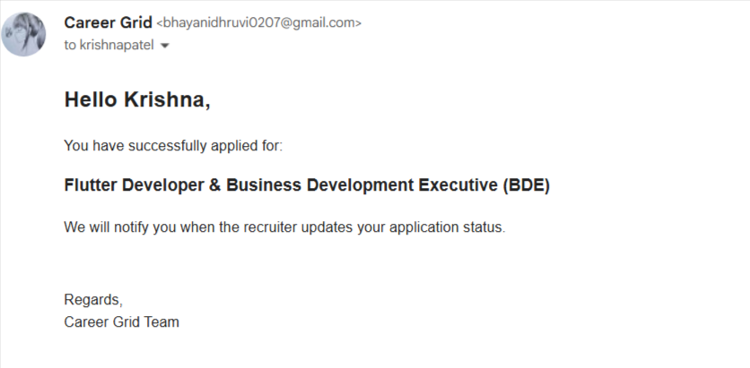

* My Applications Page

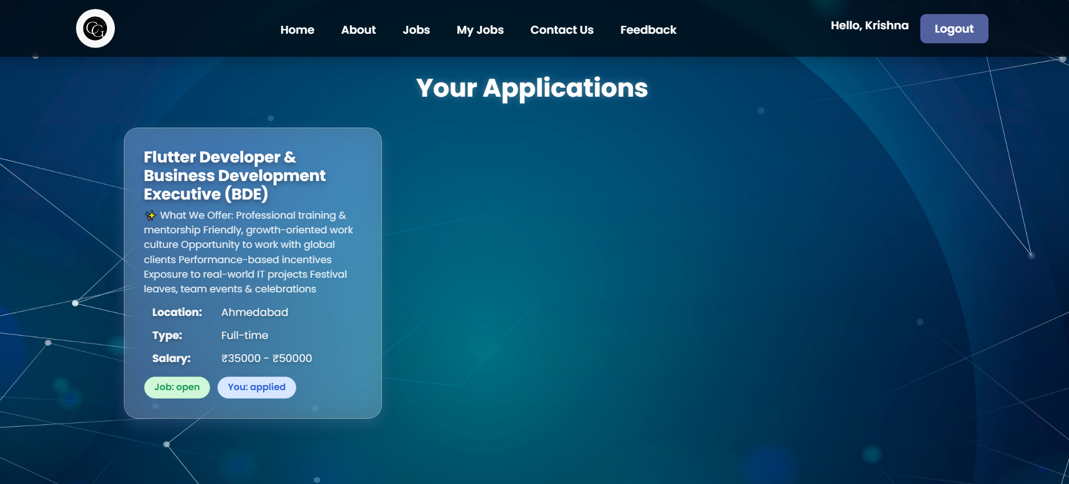

* Contact Us

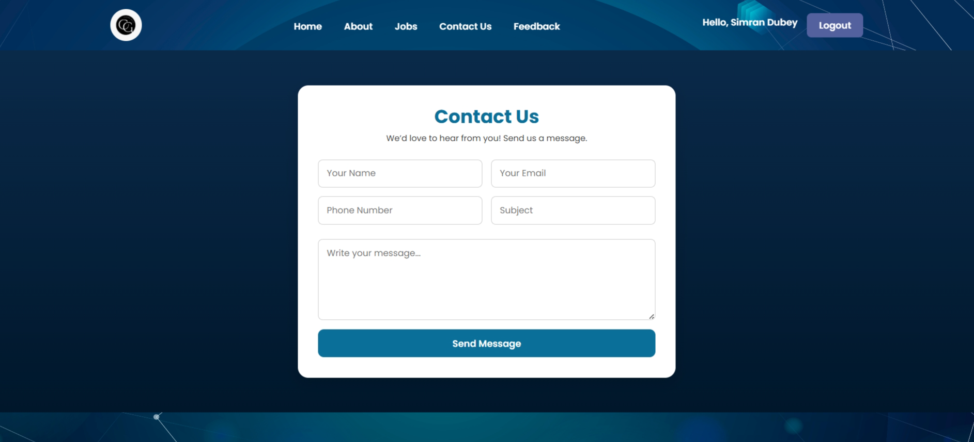

* Feedback

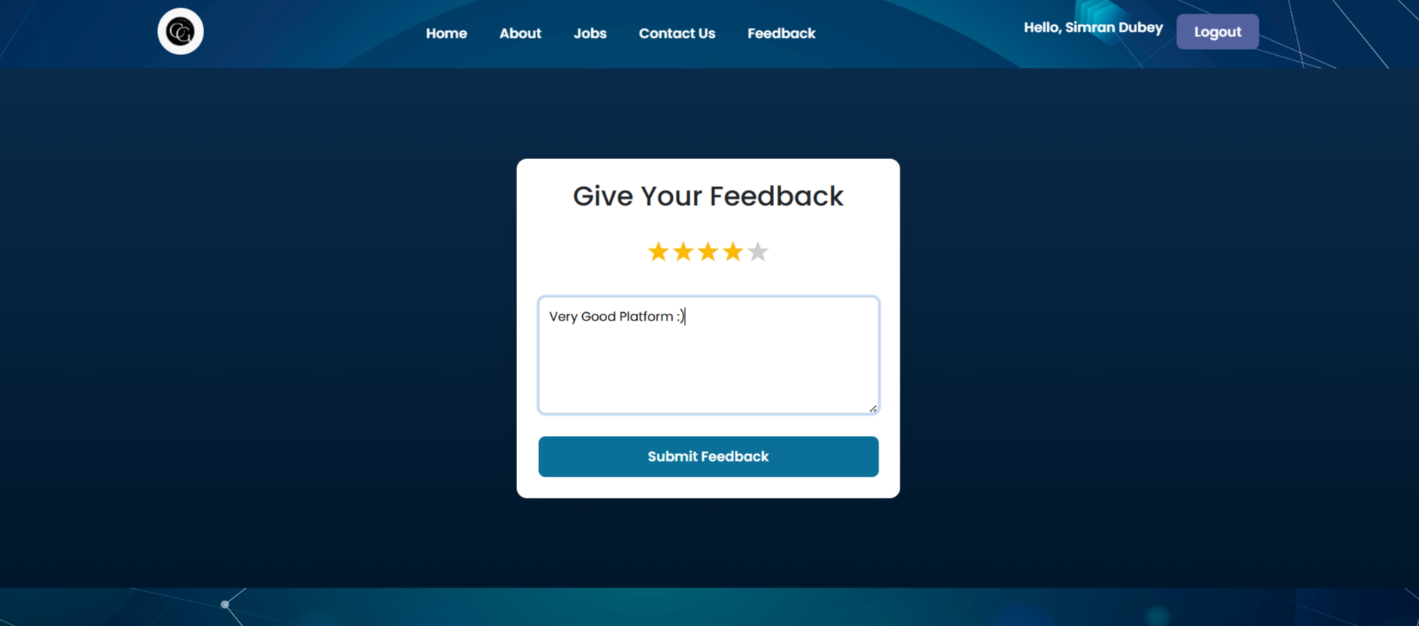

Conclusion

The **Corporate Recruitment System** streamlines the hiring process by automating job postings, applications, interviews, and feedback on a single platform. It saves time, improves accuracy, and enhances transparency, making recruitment faster, smarter, and more reliable for both companies and candidates.

BIBLIOGRAPHY

* *ChatGPT – OpenAI* (for content explanation and project guidance).
* *GeeksforGeeks* – https://www.geeksforgeeks.org (for database and system design references).
* *W3Schools* – https://www.w3schools.com (for SQL and database-related references).